We Gather as God’s People
Worship Leader - normal type. Congregational responses - bold type
*Indicates all who are able are invited to stand
GATHERING AND PRELUDE
WELCOME
God is Good All the Time
All the Time God is Good
*SONG: Here Comes the Son!
Hosanna to the Son of David! Blessed is the one who comes in the name of the Lord! Hosanna in the highest heaven! ~ Matthew 21:9
*CALL TO WORSHIP
Newtown, Boston, Texas, Oklahoma…Friends it has been a long cold, lonely winter,
Let us worship in hope of the coming Son!
It is time for the smiles to return to our faces
Let us worship in joy for the coming Son!
It is time for the ice of our doubts, our fears, our hopelessness to melt away…
Let us worship in the warmth of the Son who is here among us!
*SONG: Help
I lift up my eyes to the hills— from where will my help come? ~ Psalm 121:1
PRAYER OF CONFESSION
Gracious God, our rock and our redeemer. We have convinced ourselves that we have it all figured out – that alone we can create Your Kingdom, that we are perfect individuals and islands of fortitude. We are wrong. We do indeed “need somebody” and not just anybody, but we need You. When our best plans fail, when our loneliness overcomes our individualism, hear our cry for Help! Forgive us and remind us that it is only through you that it shall be on Earth as it is in Heaven. Amen.
*SONG OF GRACE Imagine
He will wipe every tear from their eyes. Death will be no more; mourning and crying and pain will be no more, for the first things have passed away."
~ Revelation 21:4
MOMENT WITH CHILDREN
We Hear the Good News
SCRIPTURE READING: 1 Kings 8:22-23, 41-43 pg.
SCRIPTURE READING: Galatians 1:1-12 pg.
SERMON “A Little Help” Rev. Eric Fistler
*SONG: A Little Help From My Friends
Love one another as I have loved you. No one has greater love than this, to lay down one's life for one's friends. You are my friends if you do what I command you. ~ John 15:12b-14
We Listen to God’s Still-Speaking Voice
PRAYERS OF THE PEOPLE
LISTENING TO GOD in silent prayer
Take this time to lift your prayers to God and then silently listen for God’s responses.
*SONG: Let It Be
Then Mary said, "Here am I, the servant of the Lord; let it be with me according to your word." ~ Luke 1:38

We Respond to God’s Word and Grace
OFFERING
*Doxology
Praise God from whom all blessings flow, praise God all creatures here below, Praise God above ye heavenly host. Praise Creator Christ and Holy Ghost.
*SONG: Can’t Buy Me Love
Do not store up for yourselves treasures on earth…but store up for yourselves treasures in heaven…For where your treasure is, there your heart will be also. ~ Matthew 6:19-21
*PRAYER OF DEDICATION
Take our gifts, symbols of our devotion, our wordless love, our silent thanks to you for all you have given and all we have yet to receive. Amen.

Participating in God’s Grace: Holy Communion

(God’s Table is open to everyone; all are invited to participate in Communion)
INVITATION
COMMUNION PRAYER
With grateful hearts, O God, we come to Christ’s table: remembering that you spoke creation into existence and pronounced it good; remembering that you called servants to make your world known and declared your reign; remembering that you effected salvation through Jesus Christ and reconciled us to you.
BLESSING THE ELEMENTS
LORD’S PRAYER

Our Father, who art in Heaven, hallowed be Thy Name. Thy Kingdom come, Thy will be done, on Earth, as it is in Heaven. Give us this day our daily bread, and forgive us our trespasses, as we forgive those who trespass against us. And lead us not into temptation, but deliver us from evil. For thine is the kingdom, and the power, and the glory, forever. Amen.
SHARING THE ELEMENTS
PRAYER OF THANKSGIVING
In gratitude, in deep gratitude for this moment, this meal, these people, we give ourselves to you.
Take us out to live as changed people because we have shared the Living Bread and cannot remain the same.
Ask much of us, expect much from us, enable much by us, encourage many through us. Amen.
*CLOSING HYMN All You Need Is Love
Beloved, let us love one another, because love is from God; everyone who loves is born of God and knows God. 8 Whoever does not love does not know God, for God is love. ~ 1 John 4:7-8
*BENEDICTION
POSTLUDE
NEXT SUNDAY: Children’s Sunday
10 am June 8th, 2013

West Suffield
Congregational Church
June 2, 2013

Worship with the Beatles Sunday
10:00 AM
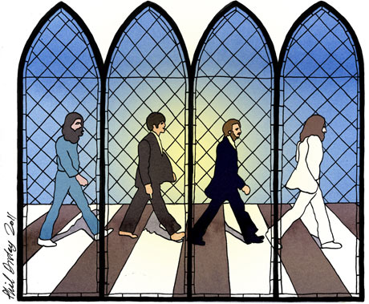
Thank you for worshipping with us today.
Whoever you are, wherever you are in life’s journey, you are welcome here!
Together, may we receive God’s comfort, challenge and inspiration through worship, word and song.

